COM535 Cyber Security Lab

- Complete the tasks – Windows Fundamentals 1 & Active Directory Basics
https://tryhackme.com/path-action/blueteam/join

Windows Fundamentals 1
https://tryhackme.com/jr/windowsfundamentals1xbx

Walkthrough Video: https://youtu.be/uqE1-ObiRHk

Active Directory Basics
https://tryhackme.com/jr/winadbasics

Walkthrough Video: https://youtu.be/T55AcTV_m7E

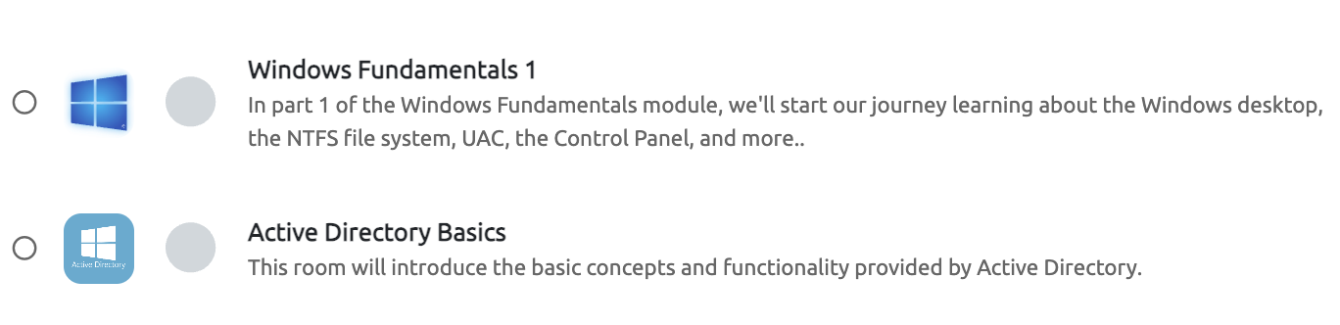

- Kenobi - Exploiting a Linux machine
https://tryhackme.com/r/room/kenobi

Walkthrough Video: https://www.youtube.com/watch?v=VAWJWPEKjvA

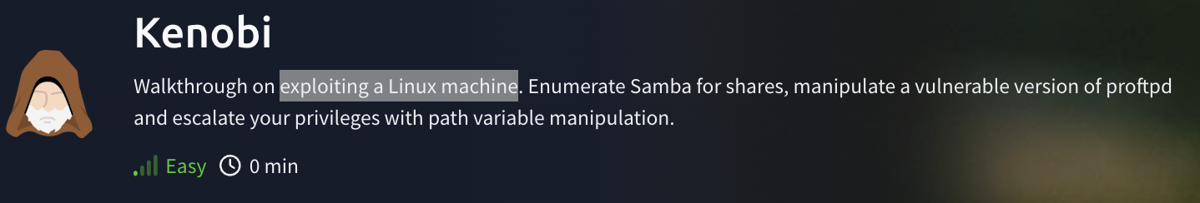

Digital Forensics & Incidence Response

- Complete DFIR – An Introduction
https://tryhackme.com/jr/introductoryroomdfirmodule

Help Video: https://youtu.be/tadg5HbFX08

- Complete Windows Forensics 1
https://tryhackme.com/jr/windowsforensics1

Help Video: https://youtu.be/uPCAv42WHT4

